RDYDTW-30kVA/100kV PD & Withstand Voltage Test Device Technical Proposal

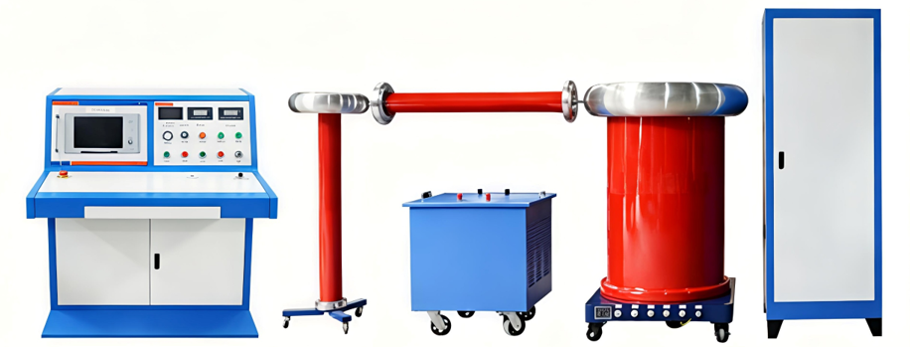

RDYDTW-30kVA/100kV PD & Withstand Voltage Test Device
I. Scope of Application
This complete set of equipment is mainly used for power products with voltage class of 35 kV and below, such as instrument transformers, power transformers, high-voltage circuit breakers, cable accessories and other test samples, to carry out power frequency withstand voltage tests, partial discharge tests and relevant scientific research tests.
II. Operating Conditions
- Altitude: ≤1000 m
- Ambient temperature: -10 ℃ ~ +40 ℃
- Relative air humidity: ≤90% (at 25 ℃)
- The waveform of power supply voltage shall be actual sine wave with waveform distortion rate less than 3%
- A reliable earthing point shall be provided with earthing resistance less than 0.5 Ω
- Installation location: Indoor

Ⅲ. Composition of RDYDTW-30kVA/100kV PD & Withstand Voltage Test Device Complete Set
- 1 set of RDYDTW-30kVA/100kV Power Frequency Partial Discharge-Free Test Transformer
- 1 set of GLB-30/0.38/0.38 Isolation Transformer
- 1 set of TEDGC-30/0.38/0～0.42 Column Voltage Regulator
- 1 set of TAWF-100/400 Capacitive Voltage Divider & Coupling Capacitor
- 1 piece of GR100-0.3/5 Power Frequency Protective Resistor
- 1 set of AC-2020 Control Unit
- 1 set of LBQ-30/0.4 Noise Filter
- 1 set of SBP-30/0.38/0.4 Triple Frequency Generator
- 1 set of Partial Discharge Detector
- 1 set of Cables and Accessories
Ⅳ. Complete Transformer Test Set and Technical Specifications
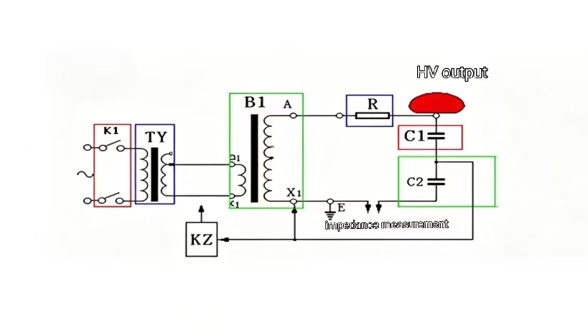
The schematic circuit of the complete transformer test set is shown in the figure below. It mainly consists of a partial discharge-free test transformer (B1), voltage regulator (TY), protective resistor (R), and capacitive voltage divider (C1, C2).
1. RDYDTW-30/100 Power Frequency Partial Discharge-Free Test Transformer
Model: RDYDTW－30/100
Structure Type: Insulated Cylinder Type
Phase Number: Single-phase
Frequency: 50 Hz
Rated Capacity: 30 kVA
Rated Input Voltage: 0.4 kV
Rated Input Current: 75 A
Rated Output Voltage: 100 kV
Rated Output Current: 0.3 A
Operating Duration: Continuous operation for 30 min under rated voltage and rated current; continuous operation permitted under 2/3 rated voltage and 2/3 rated current
Partial Discharge Magnitude: ≤3 pC at rated voltage
Power Frequency Withstand Voltage Level: 110 kV / 1 min
Voltage Distribution Non-uniformity: ＜5%
Temperature Rise: ＜45 K
Impedance Voltage: 4%–12%
No-load Current: ＜6%
Key Points of Transformer Design, Process and Manufacturing
High-voltage low-current transformers feature thick insulation for high voltage. Heat generated by coil loss is difficult to dissipate. Therefore, the current density of winding conductors shall be reduced to less than 2.2 A/mm² to cut down the load loss of the transformer.
The high-voltage winding adopts a cylindrical pagoda structure to prevent winding loosening after vacuum drying or earth discharge tests. Our proprietary winding technology is adopted, with oil duct compression structure at winding ends to avoid winding sliding and displacement.
To ensure low waveform distortion at transformer output, the magnetic flux density of the core is designed below the knee point of silicon steel sheet, with core magnetic density less than 1.5 T. The core is made of high-quality grain-oriented silicon steel sheet DQ130‑30, stacked with 45° fully mitered joints. Cutting is carried out on longitudinal and transverse Georg slitting lines to guarantee consistent rolling direction. After stacking, the core is tightly wrapped with epoxy glass tape and baked to eliminate any looseness.
The overall structure adopts an insulating enclosure. The insulating cylinder is wound with untwisted roving under constant temperature and pressure, featuring high density, low leakage current and excellent moisture resistance.
No.25 transformer oil is used for main insulation. Sealing gaskets are made of fluororubber manufactured with aerospace technology, with outstanding wear resistance, temperature resistance and voltage resistance. Hardness: 70 Shore A; tensile strength: greater than 12 MPa; elongation at break: ≥200%; permanent compression set in air: ≤35%; permanent compression set after immersion in No.25 transformer oil: ≤50%.
Strict incoming inspection is implemented for all raw materials for windings to ensure equal DC resistance of each copper wire reel. During winding, strict control is imposed on winding turns, conductor diameter, electrical conductivity and width of conductors, insulating paper and overall winding dimensions.
2. GLB－30/0.38/0.38 Isolation Transformer
Model: GLB－30/0.38/0.38
Structure Type: Metal enclosure, dry-type
Phase: Single-phase
Rated Frequency: 50 Hz
Rated Capacity: 30 kVA
Rated Input Voltage: 380 V
Rated Input Current: 79 A
Rated Output Voltage: 380 V
Rated Output Current: 79 A
Output Waveform Distortion Rate: ≤3%
Cooling Mode: Dry-type natural air cooling
3. Column Voltage Regulator
Model: TEDGC –30/0.38/0～0.42
Phase: Single-phase
Frequency: 50 Hz
Rated Capacity: 30 kVA
Rated Input Voltage: 0.38 kV
Rated Input Current: 79 A
Rated Output Voltage: 0～0.42 kV
Rated Output Current: 71.4 A
Waveform Distortion Rate: ≤3%
Initial Voltage: ≤3%
4. Capacitive Voltage Divider (Dual-purpose as Coupling Capacitor)
Model: TAWF－100/400
Rated Frequency: 50 Hz
Nominal Capacitance: 400 pF
Rated Voltage: 100 kV
Nominal Voltage Dividing Ratio: 1000:1
Measurement Error: ≤0.5% (including low-voltage arm, measuring cable and digital voltmeter)
Partial Discharge Level: ≤2 pC at 100% rated voltage
Power Frequency Withstand Voltage Level: 110 kV / 1 min
Structure Type: Insulated enclosure, oil-paper capacitive structure. Composed of top shield, capacitor body, movable base, low-voltage arm, etc.
The divider can be used as a coupling capacitor for partial discharge measurement simultaneously.
5. Transformer Protective Resistor
Model: GR100－0.3/5
Rated Voltage: 100 kV
Rated Current: 0.3 A
Nominal Resistance: 5 kΩ
Partial Discharge Level: ≤2 pC at 100% rated voltage
Structure Type: Enameled nichrome wire wound on epoxy cylinder. Connection fittings are arranged at both ends for connection with transformer and voltage divider, and shielding rings are fitted on both ends. The protective resistor will not suffer insulation damage when test sample discharges occur.
6. AC-2020 Control Unit
Model: AC-2020
6.1 Functions
6.1.1 Meter Accuracy: Class 0.5 (high-voltage measuring section)
6.1.2 Overcurrent protection equipped
6.1.3 Withstand voltage timing function available
6.1.4 The voltage regulator is driven by synchronous AC motor for voltage regulation, with upper/lower travel limit protection and zero-voltage trip protection functions.
6.1.5 The control console is provided with laboratory safety interlock door protection.
6.1.6 Zero-voltage closing function and automatic return-to-zero function upon test sample breakdown
6.1.7 Built-in withstand voltage timing module; the regulator automatically drops to zero after the specified withstand duration expires.
6.1.8 Indicators & Meters:
(1) High-voltage output voltmeter, accuracy Class 0.5
(2) High-voltage leakage current ammeter, accuracy Class 1.0
(3) Regulator output voltmeter, accuracy Class 1.0
(4) Regulator output ammeter, accuracy Class 1.0
(5) Power-on indicator
(6) Regulator reset-to-zero indicator
(7) One set of control & measuring cables supplied
7. LBQ-30/0.4 Noise Filter
Model: LBQ-30/0.4
Rated Capacity: 30 kVA
Rated Voltage: 0.4 kV
Circuit Quantity: 2 circuits
Operating Frequency: 50 Hz
Attenuation Characteristics:
≥40 dB within 40 kHz～100 kHz
≥50 dB within 100 kHz～1 MHz
Operating Duration: Consistent with the test transformer
8. RDSBP－30/0.4 Triple Frequency Transformer
Model: SBF－30/0.4
Structure Type: Metal enclosure, oil-immersed
Phase Configuration: Three-phase input, single-phase output
Rated Capacity: 30 kVA
Rated Input Voltage: 380 V three-phase
Rated Input Current: 45.5 A
Output Frequency: 150 Hz
Rated Output Voltage: 400 V single-phase
Rated Output Current: 43.3 A
Output Waveform Distortion Rate: ≤3%
9. Partial Discharge Detector
Applicable capacitance range of test samples: 6 pF～250 μF
Detection Sensitivity: ＜0.02 pC (for 50 pF sample capacitance)
- Equipped with color display supporting dual-color waveform for clearer visualization;
- Waveform hold function to facilitate detailed observation of discharge waveform features;
- Automatically measures and displays time-base frequency of test power supply without manual switching;
This instrument features high detection sensitivity and wide applicable sample capacitance range, covering various types of test objects. Complete input units (detection impedances) and nine optional frequency band combinations are provided. After proper calibration, the instrument can directly read the apparent charge magnitude of discharge pulses.
Main Technical Specifications:
- Capacitance range of testable samples: 6 pF ~ 250 μF
- Detection Sensitivity (Table 1):
Table 1：
Input Unit No. | Tuning Capacitance | Unit | Sensitivity (pC)  (Asymmetric Circuit)
1 | 6–25–100 | pF | 0.02
2 | 25–100–400 | pF | 0.04
3 | 100–400–1500 | pF | 0.06
4 | 400–1500–6000 | pF | 0.1
5 | 1500–6000–25000 | pF | 0.2
6 | 0.006–0.025–0.1 | μF | 0.3
7 | 0.025–0.1–0.4 | μF | 0.5
8 | 0.1–0.4–1.5 | μF | 1.0
9 | 0.4–1.5–6.0 | μF | 1.5
10 | 1.5–6.0–25 | μF | 2.5
11 | 6.0–25–60 | μF | 5.0
12 | 25–60–250 | μF | 10
7R | Resistor | — | 0.5
3. Amplifier Frequency Band
(1) Low cut-off frequency: Optional 10 kHz, 20 kHz, 40 kHz
(2) High cut-off frequency: Optional 80 kHz, 200 kHz, 300 kHz
4. Amplifier Gain Adjustment
There are 6 coarse adjustment gears with inter-gear gain of 20±1 dB; fine adjustment range ≥20 dB.
The reading ratio between adjacent gears is 10:1. For example, if the reading on Gear 3 is 98, the reading on Gear 2 will be 9.8. If the measured reading on Gear 3 exceeds 120, switch to Gear 2 for measurement, and multiply the displayed reading by 10 to obtain the actual measured value.
5. Time Window
(1) Window width: Adjustable range 15° ~ 175°
(2) Window position: Each window can be rotated from 0° to 180°
(3) Two time windows can be enabled separately or simultaneously.
6. Discharge Meter
Error: < ±3% (full scale)
7. Elliptical Time Base
(1) Frequency: 50 Hz, or external power supply synchronization (any arbitrary frequency)
(2) Ellipse rotation: Adjustable in 30° steps for full 360° rotation
(3) Display mode: Ellipse / Straight line
8. Test Voltmeter
Accuracy: Better than ±3% (full scale)

